
Origin Labelled Products
in the European Union
The web site of the European Concerted Action
Development of Origin Labelled Products:
Humanity, Innovation and Sustainability
http://www.origin-food.org

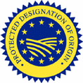 | + | 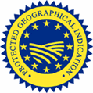 | + |  | Non-certified  Regional Products  based on Codes  of Practices
Protected Designation of Origin - Protected Geographical Indication Regulation EEC No 2081/92 |  |  |  | Non-certified regional products

A multidimensional project :
- Definition, Characteristics, legal Protection  - Link with Production-Marketing System  - Link with Rural Development  - Link with Consumers, Citizens  - Characteristics, evolution problems, opportunities  - Policies evaluation  - Synthesis and recommendations  - Information and dissemination | 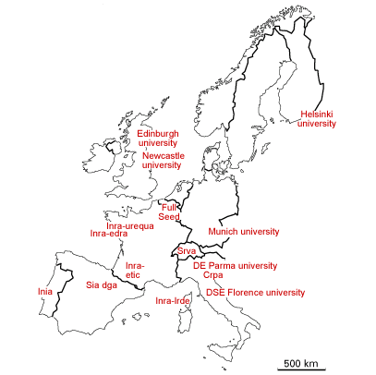  A network of 9 Countries:

Three free European’s databases:
©Fond de carte Hachette

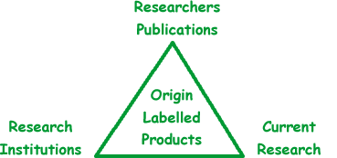

5th PCRD OFES
Contact: webmaster@origin-food.org Timetable: December 2000 to December 2003
A European Union concerted action QLK-2000-00593 financed by the fifth framework of the European Community for research, technological development and demonstration activities (1998-2002) and by the OFES of Switzerland

